**Requirement Refined**

The main purpose of this Android app is to allow users to write a good text message on this software, and set the contact of the text message and the specified sending time. The software will automatically send the mobile phone text message to the contact's mobile phone at the specified time. The program must be written in nativescript javascript, don't use other languages. At the same time only need Android.

priority:

1. Automatically send SMS and send the sent SMS message from the future message to message history

2. Repeat function

Home interface

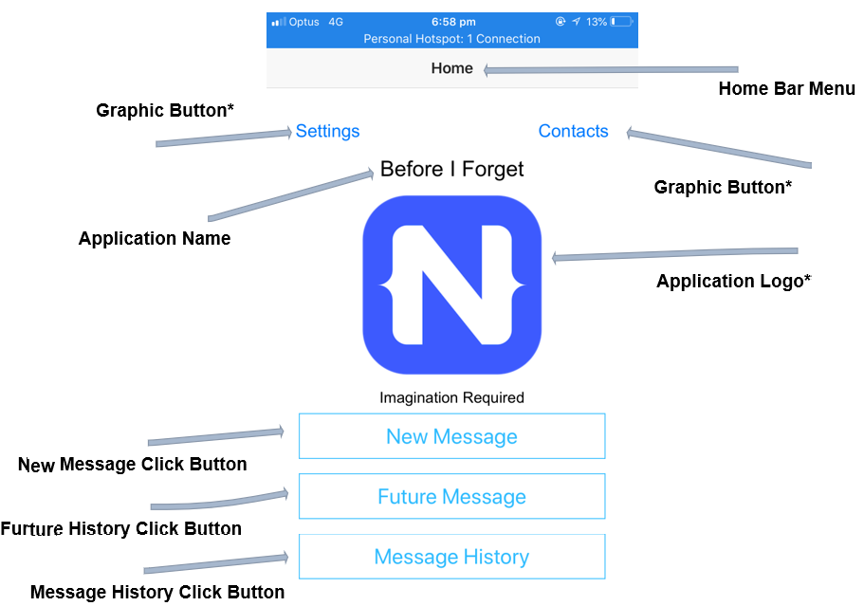

New message interface

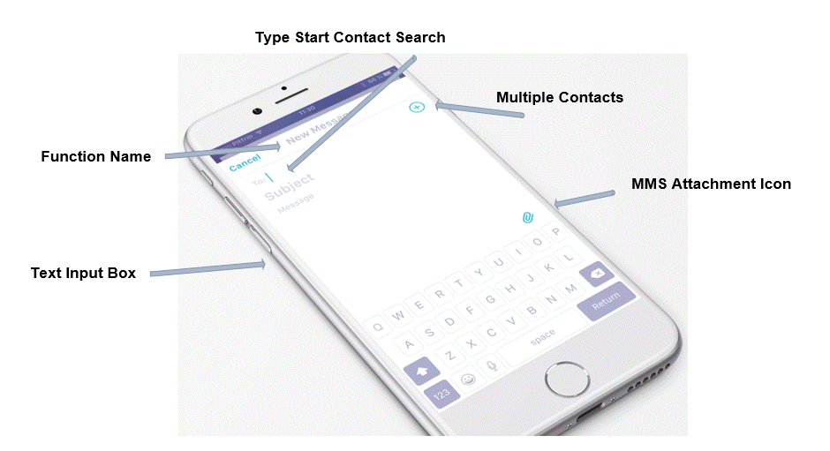

Edit the message and press the next button to the next screen: send the time and date (this picture takes less time). The following repeat function will appear on one day before, one hour before two options (can be selected at the same time). These two options mean that the user will be prompted to have a text message to be sent one or one hour before the message is sent.

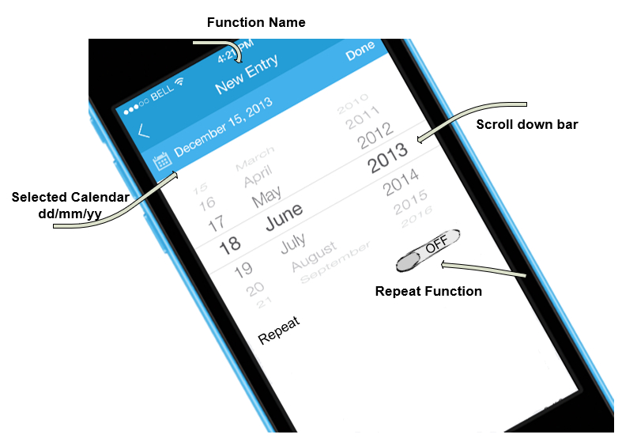

**Future message and history message interface:**

This is to display the set SMS

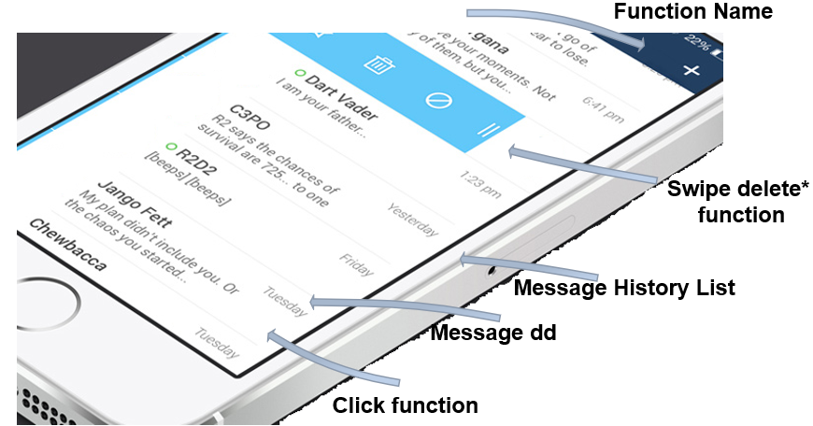

After clicking the information, it will enter the view mode. It is not editable in the view mode. It can be edited and saved when the edit button is pressed.

When the message is sent, the information in the future message will be transferred to the history message.

The History message is also the same design, but when the message is edited and saved, a new message is displayed to the future message.